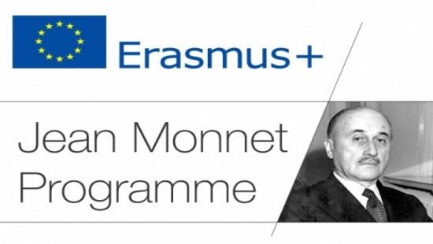

INFORMATION LETTER

The project team “Jean Monet Chair “European Diplomacy” announces the holding of The III International Distance School “Relevant Problems of European Integration and Diplomacy” for teachers of secondary schools, colleges, universities of Central Asia from April 19 to May 01, 2021. This school is provided by the implementation plan of the project “Jean Monet Department of European Diplomacy” and is co-financed by the European Commission as part of the Erasmus + Program.
The distance school has the goal of expanding the competence of teachers in the field of history, the current state of integration processes and diplomacy in the framework of the European Union. The school aims to create optimal conditions for education workers to receive reliable, relevant information on integration processes in the EU and European diplomacy without interruption from their main work.
Teachers of secondary schools, colleges and higher educational institutions of the Central Asia countries are invited to participate in the work of the distance school.
Language of participation: Kazakh, Russian, English.
Amount of hours: 72 hours.
Applications for participation in the distance school are accepted by the organizing committee until April 12, 2021 by e-mail: gulsum-1983@mail.ru.
According to the results of participation in the school, certificates will be awarded.
Phones of the organizing committee:
+7 701 393 81 71 Medeubayeva Zhanar Muratbekovna.
+7 701 807 76 06 Kenzhalina Gulsum Zhumabayevna.

Application for participation:

1 | Name
2 | Country, city
3 | Place of work
4 | Position
5 | E-mail address
6 | Phones
7 | Special wishes

